 | Year 12 Mathematics Essentials  Response (Test)  Measurement

Student Name:

Materials Allowed: | Pens, pencils, rulers, scientific (non-programmable) calculators, one single sided A4 page of notes
Time Allowed: | 55 minutes | Score: | /48
 |  | Percentage: | %

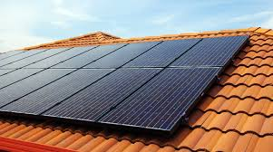
Not another bill! You have had it! The cost of power, water and fresh food is rising, and you want to do something about it. You decide to install solar panels on your roof, a new rainwater tank and some garden beds in which to grow fresh vegetables.
INSTALLING SOLAR PANELS
QUESTION 1 (11 marks)
Solar panels are installed using a modular design. Customers purchase multiple standard rectangular panels to meet their energy requirements. They can be installed in either a vertical or horizontal orientation (upright or on their side).
Scale of 1:10

- Determine the area of the standard rectangular solar panel in $m^{2}$

(4 marks)
- Your north facing roof has a rectangular shape with the dimensions as given on the following diagram.

3.5 m

11 m

Determine the maximum number of panels that can fit on the roof. Justify your answer.

(5 marks)
- If each panel costs $435, and installation costs $650, determine the total cost for the installation and supply of the solar panels.

(2 marks)
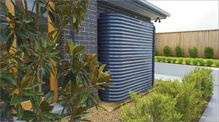
PURCHASING A RAINWATER TANK

QUESTION 2 (20 marks)
You have two options for purchasing a rainwater tank. One is an innovative triangular design that fits into the corner between two walls. The other is the modern rainwater tank design that fits closely to the house and is cheap to build.
[INSERT PICURES OF DESIGNS HERE – ONE TRIANGULAR PRISM (cm), THE OTHER A COMPOSITE SHAPE OF A RECTANGULAR PRISM WITH SEMI-CIRCULAR ENDS (m))

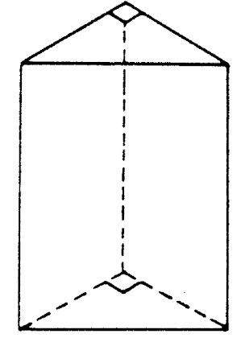
80 cm
90 cm
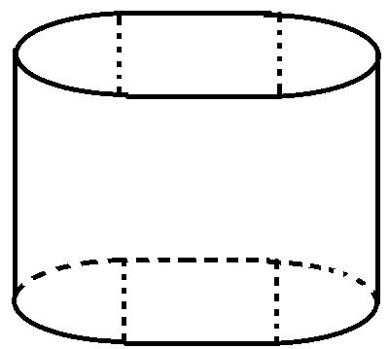
0.4 m

1.0 m
150 cm

1.2 m

TRIANGULAR DESIGN | MODERN DESIGN

- Determine the volume of the triangular design in $m^{3}$

(3 marks)
- Determine the volume of the modern design in $m^{3}$.

(6 marks)
You decide to opt for the modern design as it is cheaper and will fit alongside your house.
- Determine the capacity of the modern design in litres (L)

(1 mark)
- You wish to have your rainwater tank painted. Determine the surface area of the tank.

(6 marks)
- If it costs $20.99 for one tin of paint (each tin is 2L), and one litre can cover 1.5$m^{2}$, determine the cost of paint required to paint the tank if three coats of paint are required.

(4 marks)

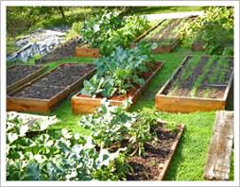
BUILDING A RAISED GARDEN BED

QUESTION 3 (17 marks)
You wish to buy a pre-made raised garden bed, but you do not like the look of the wood or metal designs. You find a ceramic option which comes in a trapezium prism design. A three-dimensional view is shown below.
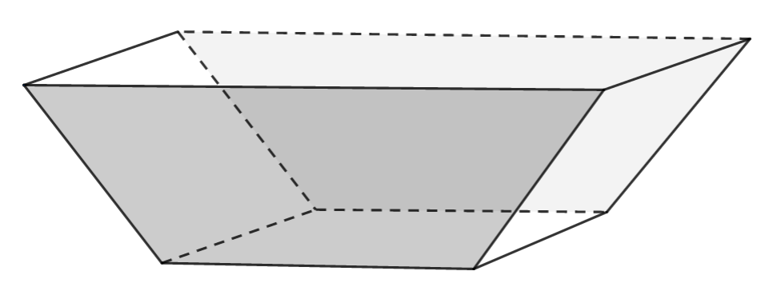
70 cm
170 cm

47.7 cm
50cm

70 cm
140 cm

- Draw a scale diagram of the side view showing the trapezium face of the garden bed. Use the scale 12.5:1

(4 marks)
- The inside of the garden bed will be lined with thick, black plastic sheeting to protect the ceramic from acids in the soils. Determine the total area of black plastic sheeting in $cm^{2}$ required if the bottom and four sides need to be covered completely.

(4 marks)
- The manufacturer stated that the volume of the garden bed is 518 L. What is wrong with their statement?

(1 mark)
- The garden bed will be filled with soil so that it is 90% full. Determine the volume of soil required in $cm^{3}$.

(3 marks)
- You wish to place some vegetable seedlings into the now filled garden bed. On the punnet of seedlings, the instructions tell you that each seedling must be planted so that they are 10cm from each other seedling and 10cm from the edge of the garden bed. Determine the number of seedlings that can be planted in the garden bed. Justify your answer. (A top-down view of the garden bed at the soil level is shown below to help you)
1670 mm

700 mm

(3 marks)
- You wish to connect piping to provide water to the plants. Using the diagram above, determine the length of piping required (in metres) if the pipes are placed against the edges of the garden bed.

(2 marks)

